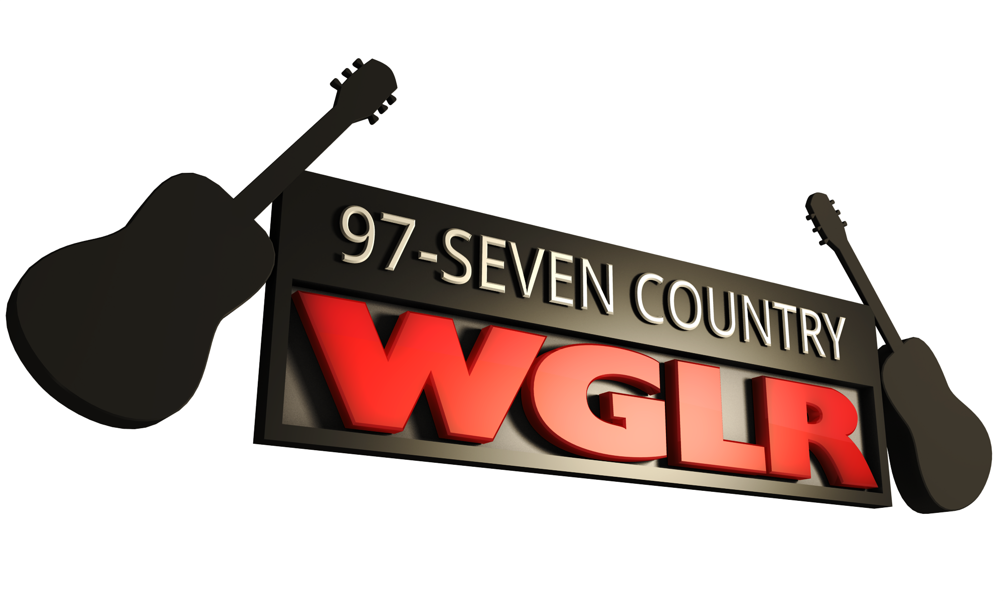

- WGLR will accept nominations from listeners.

- All entrants will be judged on information received on the attached nominating form, accompanying letter, and/or other information solicited by the Farm Family of the Year Judges.

- The Farm Family of the Year winner will receive a plaque along with other prizes provided by the Farm Family sponsors.

- The decision of the Judges is final.

- To be eligible for the award, the nominee must meet the
definition of a “Farmer.”

The purpose of the Farm Family of the Year awards is to foster better urban/rural
relations by creating a greater public interest and understanding of today’s farm family.

Vital Statistics of the “Farm Family” nominated by you:

Farm Family: ________________________________________________________________________

Address: ____________________________________________________ County: ______________

Town/State/Zip: ___________________________________________ Phone: __________________

Location: ____________________________________________

Wife’s Name: ________________________ # of Children: _______ Ages: _________________

Number of years in actual farm operation: ___________________

Percentage of total annual income earned from farming: _______________________________

Type of farming: _____________________________________________________________________

# of Milk Cows: ____________ # of Beef Cattle: ____________ # of Hogs: _______________

Other Livestock: _____________________________________________________________________

# of Acres Operated: ______________ Tillable: _____________ Pasture: ______________

Goals of the Farm Family: ____________________________________________________________

_____________________________________________________________________________________

______________________________________________________________________________________

What obstacles, if any, has the family had to overcome? _______________________________

______________________________________________________________________________________

______________________________________________________________________________________

Has the nominee experimented with any new farming practices? _______________________

______________________________________________________________________________________

______________________________________________________________________________________

How is the farm family actively involved in community and/or farm organizations? _______

______________________________________________________________________________________

______________________________________________________________________________________

Farm pictures are welcome, but cannot be returned. Please feel free to supply additional information
such as a letter, awards won, etc. Applications must be returned by Friday, June 4, 2021
Please return nomination forms to:

97 Seven Country WGLR
c/o Farm Family of the Year
51 Means Drive, Platteville, WI 53818
Phone: 608-349-2000 Fax: 608-349-2002

