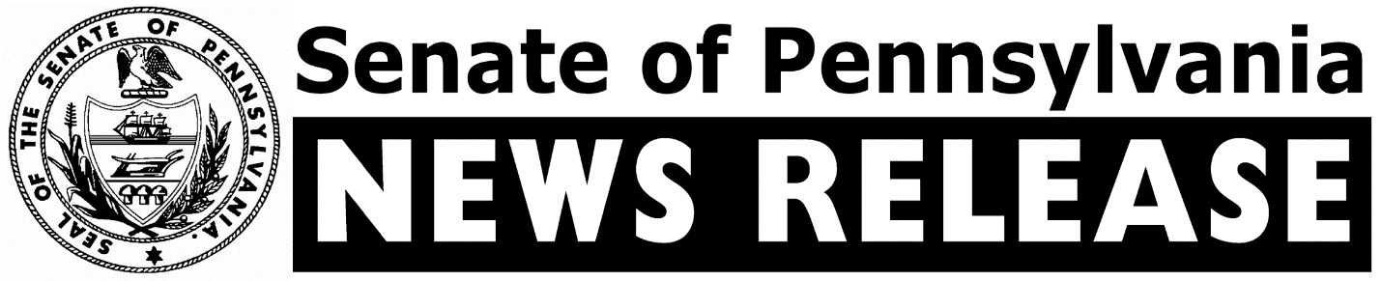
FOR IMMEDIATE RELEASE
February 16, 2021

IRRC Calls for Delay of RGGI, Questions Wolf’s Authority to Impose Rule

HARRISBURG – The independent commission charged with reviewing proposed state rules and regulations today called for a one-year moratorium on the implementation of Governor Wolf’s mandate that Pennsylvania join the Regional Greenhouse Gas Initiative (RGGI) and questioned the Governor’s unilateral decision to join the compact without legislative approval, according to Sen. Gene Yaw (R-23), Chair, and Joe Pittman (R-41), Vice Chair, of the Senate Environmental Resources and Energy Committee.

The delay and questions about the Environmental Quality Board’s (EQB) authority to impose a regulation to establish a program to limit the emissions of carbon dioxide from electric generation (Regulation #7-559) were part of a nine page comment document issued by the Independent Regulatory Review Commission (IRRC), the senators said. At its September 15, 2020 meeting, the EQB considered and approved the proposed regulation – over the previously filed objections from three advisory panels in the Department of Environmental Protection (DEP).

On October 3, 2019, Governor Wolf directed DEP to join RGGI – a collaboration of Northeast and Mid-Atlantic states. The states (Connecticut, Delaware, Maine, Maryland, Massachusetts, New Hampshire, New York, Rhode Island, Vermont, and, more recently, New Jersey and Virginia, set a cap on total carbon dioxide (CO2) emissions from electric power generators in their states. In order to comply, power plants must purchase a credit or “allowance” for each ton of CO2 they emit, which changes every calendar quarter through auctions conducted by RGGI. Pennsylvania would be the only state in the compact with a substantial amount of coal or natural gas resources and, as a result, electric generation plants fueled by those resources.

“These critical IRRC comments, and its recommendation for a one-year delay, are quite timely given the ongoing and catastrophic blackouts in Texas, which were caused by that state’s transition from reliable and resilient coal generation to unreliable wind and solar power, much as Governor Wolf intends with Pennsylvania’s entry into RGGI,” said Senator Yaw. “During Pennsylvania’s last polar vortex, it was coal generation that absorbed three-quarters of the historic increase in demand for electricity, since nuclear power cannot be increased and significant amounts of natural gas had to be rerouted from power plants to home heating. These issues must be thoroughly analyzed by the General Assembly, the Public Utility Commission and PJM.”

“There is a lot of information in the report and it clearly shows that the IRRC thoughtfully considered all of the facts and details presented on the proposed regulation,” said Senator Pittman. “But the biggest piece is the IRRC recommendation that any RGGI rule have its implementation delayed by a year. There are several other items of note in the report, but the main take away is that IRRC certainly recognizes the significant impact of Pennsylvania entering into RGGI and that it must be done thoughtfully.”

In addition to asking the EQB to consider delaying the implementation of the regulation for one year, the IRRC also directed the EQB to provide details on the Governor’s unilateral decision to join RGGI without legislative approval and to explain how it was empowered to develop the regulation, despite the rejection of the proposal by three DEP advisory panels. The IRRC noted that prior to being presented to the EQB for consideration, the three panels (the Air Quality Technical Advisory Committee, the Citizens Advisory Council, and the Small Business Compliance Advisory Committee) all declined to support the rulemaking.

The IRRC comments also considered objections raised by several parties of whether the proposed regulation represents a policy decision of such a “substantial nature” that it requires legislative review and acknowledged a point raised by a Pennsylvania Senate letter that “the proposed regulation joining Pennsylvania to RGGI represents the single, most significant energy policy reform since the deregulation of electric generation in the 1990s.”
“The issues raised by members of the General Assembly, the legislative action from the last session of the General Assembly, the lack of consensus from three EQB advisory panels and the manner in which other states have joined RGGI clearly indicate that this regulation falls within the scope of that criterion,” the comments stated. “We ask the EQB to explain why it is appropriate to implement this carbon trading program through executive order and the rulemaking process instead of the legislative process.”

After reviewing the points raised by both sides regarding EQB’s statutory authority granted by the Air Pollution Control Act (APCA), the Commission directed that agency to consider all of the arguments on both sides of these issues and provide a point-by-point analysis of why this proposal is within its delegated authority and to show that it is consistent with the intent of the General Assembly when the APCA was enacted.

# # #

CONTACTS:
Nick Troutman (Senator Yaw)
ntroutman@pasen.gov
Jeremy Dias (Senator Pittman)
jdias@pasen.gov

