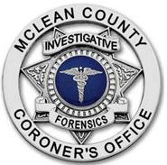
Kathleen Yoder, DNP
CORONER
Office (309) 888-5210 104 W. Front St.
FAX (309) 888-5090 P.O. Box 2400
Kathleen.Yoder@mcleancountyil.gov Bloomington, IL 61702-2400

McLean County Coroner Dr. Kathy Yoder is releasing the following information regarding the identity of the person that was found lying in the roadway of the 600 block of W. Seminary Avenue, Bloomington, Illinois on April 9, 2021.
Pronounced deceased on April 9, 2021, was Dale E. Baughman, age 59, of Normal, Illinois. Preliminary autopsy opinion indicates that Mr. Baughman died of multiple stab wounds. This incident remains under investigation by the McLean County Coroner’s Office and the Bloomington Police Department.
Thank you.

