May ‘17 Volume 21.5
INSIDE
1 | Emily Watts Sport Award
2 | Dear Phil
3 | 2BS Programs
4 | B-Rock Programs
5 | 2BS / B-Rock Contacts
The Radio Station News

SARAH IS MISS ROYAL BATHURST SHOWGIRL
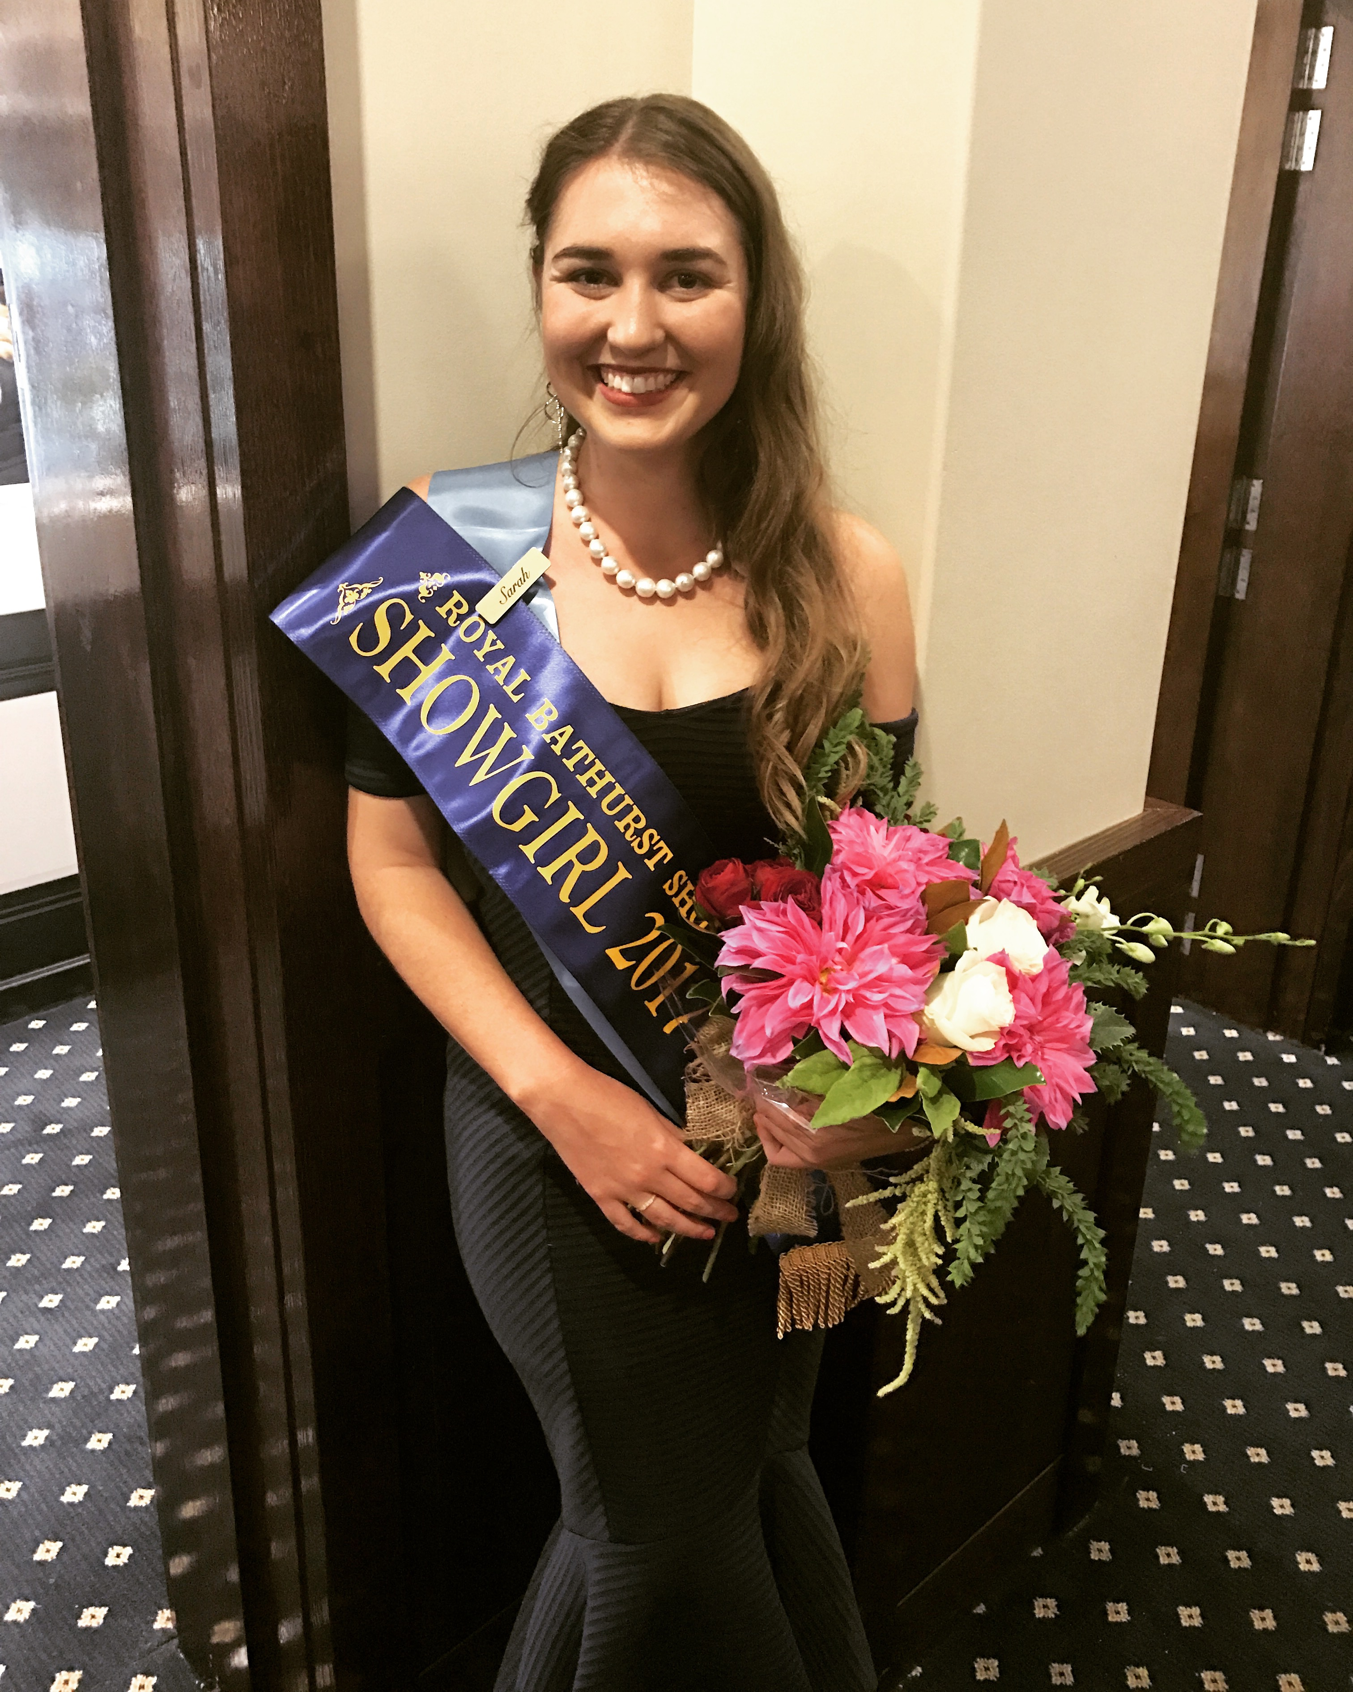
“Talk of the Town” afternoon host on 1503 2BS Gold, Sarah Boorer won the Miss Royal Bathurst Showgirl Competition.
Sarah was one of six girls who entered the competition, with judging taking place on Saturday, April 22nd before the Presentation Dinner at the Bathurst RSL Club.
Sarah says, “she is honoured to be announced the winner and can't wait to see what experiences the role brings. It is a great way to get to know the Bathurst community while promoting what the region has to offer”.
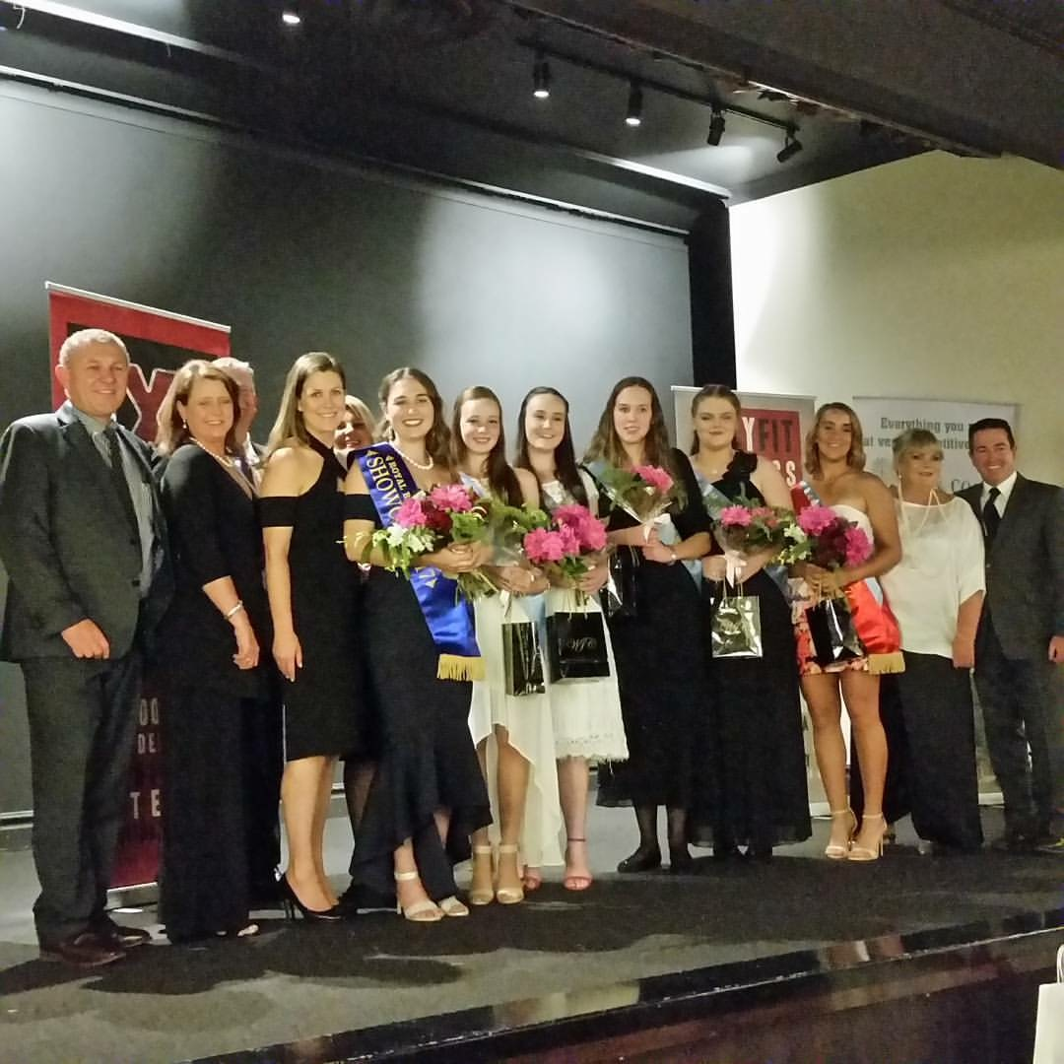

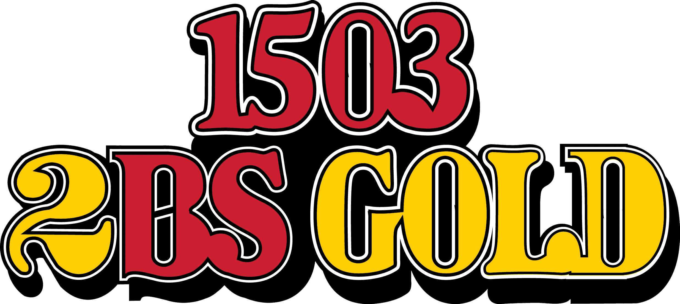

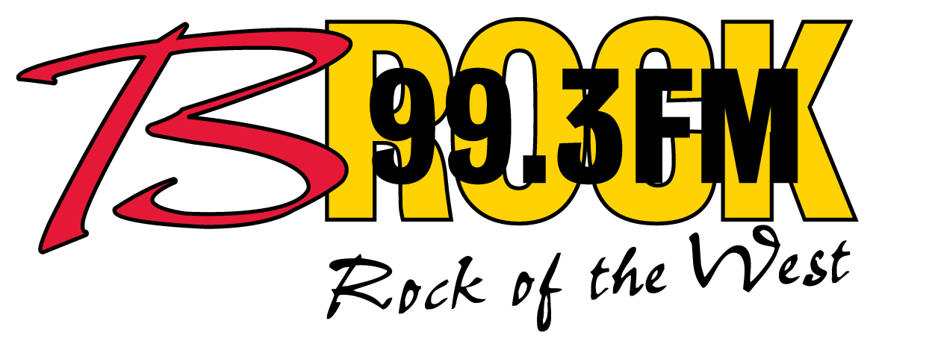
B-ROCK - HOME OF MOTORSPORT
With the recent growth of the Bathurst 12 Hour, the Bathurst 6 Hour and 1503 2BS Gold’s weekend program commitments, motorsport including the Bathurst 1000 will in future be heard on 99.3 B-Rock FM.
General Manager, Phil Cole says, “we are really excited about this change, it means programs like, Ray Hadley’s Morning Show, Chris Smith Afternoons and The Continuous Call Team and The Summer Edition of The Continuous Call team can in future run uninterrupted on 2BS”.
Phil says, “given B-Rock was named after the King of the Mountain Peter Brock, it is appropriate that our award winning race commentaries have finally found their way there”.

SUCCESS STORY
Advertising with 2BS & B-Rock has once again proved successful.
It worked when we wanted to let our customers know we now have an experienced Diamond buyer in store, and it worked when we promoted our recent Pandora Rose VIP Event.
I’m certain Radio advertising is now an essential part of my business.
It works for mine and it will work for yours.
Call one of their friendly representatives today on 6331 7777.
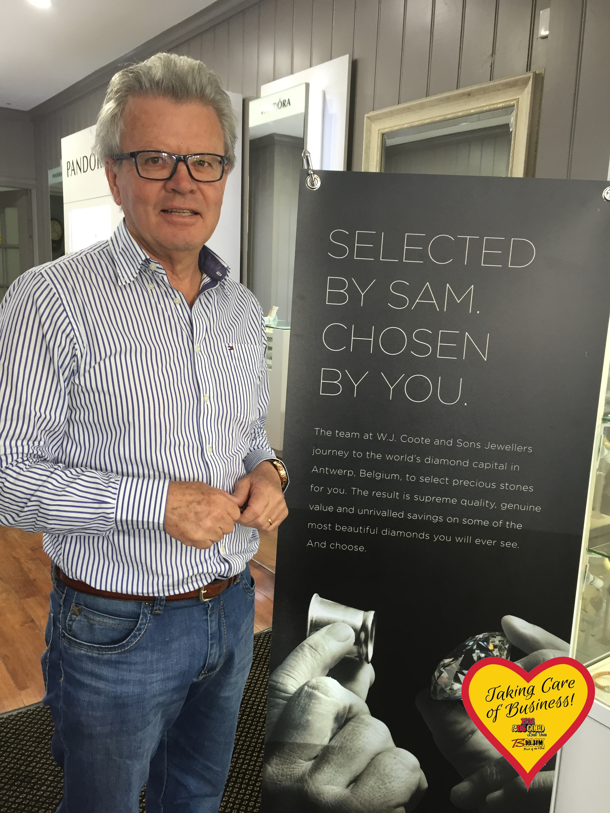
Sam Coote, Proprietor, WJ Coote & Sons Your Showcase Jeweller.

EMILY WATTS RECEIVES BATHURST JUNIOR SPORT AWARD
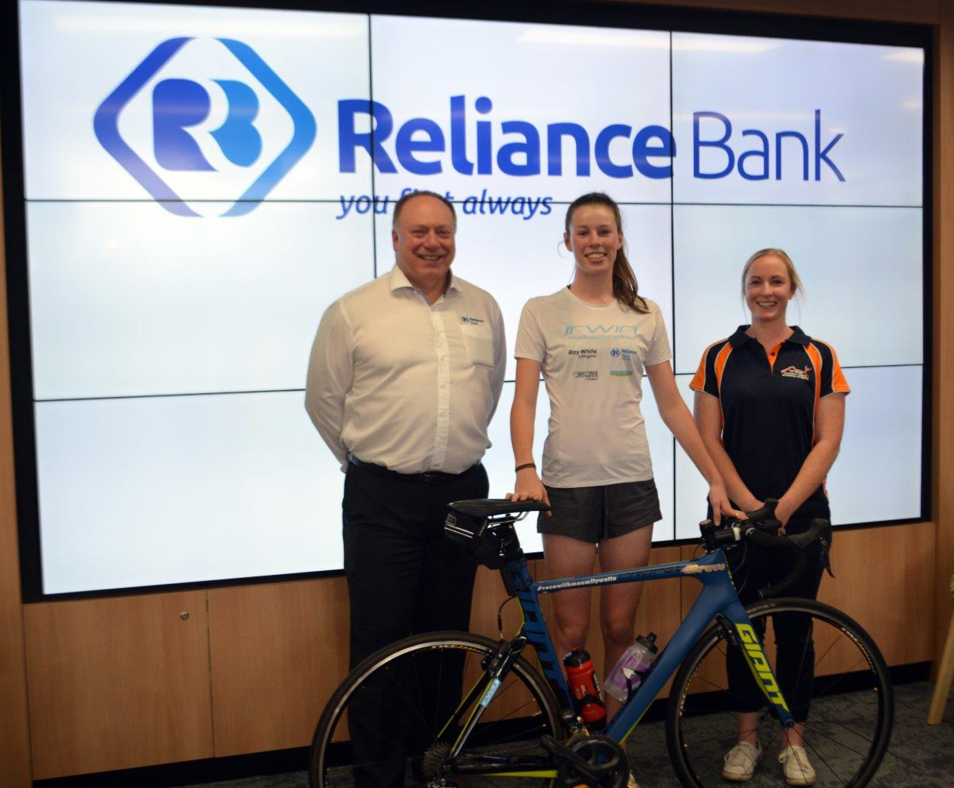
Clinton Blanks (Reliance Bank), Emily Watts and Candice Boss (Western Region Academy of Sport).

DEAR PHIL
On behalf of the Lachlan Endurance Rider’s Club, I would like to express our sincere appreciation for your sponsorship of our second prize horse rug at the Neville Endurance Ride weekend in March.
Without the help of generous donations like yours, running a financially viable ride would be an increasingly difficult thing to do.
The ride was an extremely successful event, with a combined 184 riders entered.
Even the little bit of rain could not dampen the spirits of the riders and an enjoyable weekend was had by all.
Erica Allen, Secretary, Lachlan Endurance Riders Club Inc.

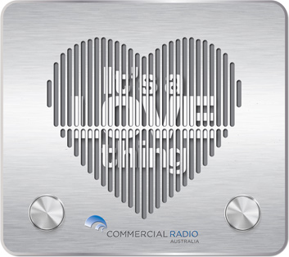

PROGRAMS

Monday to Friday
- “The Breaky Show” with Ardin 6a-9a
- “Ray Hadley Morning Show” 9a-11a
- “Alan Jones Show” 11a-12noon
- “Chris Smith Afternoons” 12noon-3p
- “Talk Of The Town” with Sarah 3p-6p Mon-Thu
- “Bangers & Mash” with Janeen and Pete 3p-6p Fri
- “Money News” 6p-8p Mon-Thu
- “Nights with Steve Price” 8p-12a

Other Highlights
- “Continuous Call Team” 7p-10p Fri, 12p-10p Sat, 12p-6p Sun
- “My Generation” 9a-11a Sun
- “Home Made Jam” 6p-7p Sun


Monday to Friday
- “Benny and the B-Rock FM Morning Show” 6a-10a
- “Rock Work Day” with Sarah 9a-1p
- “Rock Work Day” with Deek” 1p-5p
- “Fitzy & Wippa” 5p-6p
- “The Rock Shop” 6p-12a
- “The NightShift with Luke Bona 12a-5.30a

Other Highlights
- “The Most Wanted Countdown” 8p-10p Fri / 4p-6p Sun
- “The Sporting Probe” 8a-10a Sun

CONTACTS
Directors / Owners
Ron Camplin Stephanie Camplin
General Manager / National / Contra
Phil Cole
Director of Sales / Local
Janeen Hosemans
Operations Manager / Technical
Dom Ingersole
Program / Content Director
Ardin Beech – 2BS
Music Director
Benny Hope
Marketing Consultants
Janeen Hosemans Janie Birchall Bron Davey
Marketing Assistants
Alexis Le Masson Sarah Connor Lucy Ryan
Copywriter
Daniel King
Commercial Production
Nicolas Cook
Accounts / Traffic Manager
Jena Shaw
Receptionist / Program Producer
Natalie Pilato Harrison Carter
Announcers
Ardin Beech Sarah Boorer Janeen Hosemans Peter Harrison Phil Cole Bron Davey Harrison Carter Patrick Harrison Benny Hope Dom Ingersole Nicolas Cook Daniel King Darren Webster
Jena Shaw Sarah Connor

Telephone (02) 6331-7777
Fax (02) 6332-1503
www.2bs.com.au www.brockfm.com.au www.radioredpages.com.au

